Information for Scouts Seeds to Trees Mission with Houston Wilderness
Scouting's Spring of Service is a program started in Spring 2022 and continuing at Houston Wilderness as our Seeds to Trees Mission.
Houston Wilderness invites Scouts to consider this new endeavor called Seeds to Trees Mission where scouts will sow (push into the ground) existing seeds. This program is geared towards younger Scouts and allows them a chance to ‘plant trees’ without the laborious work of tree planting at some of our other events.
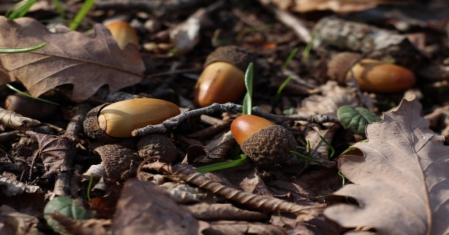
The task is simple: Scouts will find ‘mother trees’, pick up seeds, and push them into the ground all around the area they choose!
Items to Consider in choosing the Seeds to Trees option:
- DATES: This project allows for a lot of flexibility. You can choose a date that best fits your group; consider the weather and location to ‘mother trees’ for the seeds.
- AGE RANGE:. Tree planting can be laborious work so we are offering this as a chance for younger scouts to get outside and plant trees.
- How to: First, let us know you are interested in leading your independent Seeds to Trees mission here.
Then choose a location where you think your scouts can find ‘mother trees.’ Mother trees are older, seeding trees. Houston Wilderness has put together a Wilderness Passport to help guide you in choosing outdoor areas. The Wilderness Passport lists state parks, wildlife refuges, museums, arboretums, and nature centers in each of our 7 land-based and 3 water-based ecoregions.
If you would like, we can mail you as many Wilderness Passports as you’d like as well as laminated copies of our Seeds ID guides!
- WHY SEEDS TO TREES?
You can help make a difference by doing something as simple as pushing seeds into the ground! While birds, squirrels, and other native animals are already doing this work, there are a ton of seeds that annually are picked up by lawn services or land on pavement and never have the chance to sprout. Using our HSC Seeds to Trees Mission Seed guide, we invite you to visit a local park/green area and help push seeds in the ground! Leaders can make an outing of finding the seeds with our guide, count the amount of seeds sown, and complete our Seeds to Trees survey afterwards to help us count how many trees you ‘planted’ by sowing their seed.
- SUPPLIES & HW REQUIREMENTS: Houston Wilderness is happy to provide passports to all scouts involved; please fill out if you would like passports and how many in our form.
FINISHED collecting and ‘planting’ seeds? Let us know how you did in our Seeds to Trees survey.
Completing this survey is our proof that you participated in this program for any Scout credit necessary.
To begin your service project under Houston Wilderness:
Fill out the form here to let us know about your Unit and to choose which project you will participate in.
Use the Seed ID one pager, our passport for locations to visit, and the Survey to help guide you. Seeds to Trees groups should follow all Boy Scouts of America volunteering protocols.
The leader is responsible for recruitment of scouts as volunteers and ensuring all individuals signed up for either project have their correct paperwork/waivers turned in that are appropriate to the project they choose.

Please email Ana Tapia at Ana@houstonwilderness if you have any questions and of course, complete your interest form here. We hope to continue making a difference in Houston with you!

